Power Automate Flow:

Flow Name: (Updated Version) Push Notification to Teams when Opp Closes as WON

------

Action being call: ss_TeamsNotificationOnOpportunityWon

-----

Flow Name: Update Opportunity Set New Won Opp

----

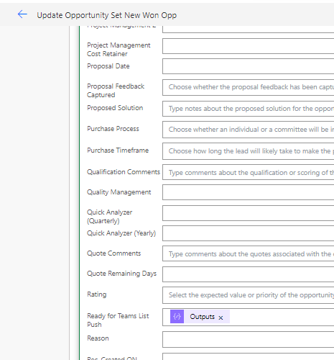

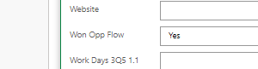

Flow Name: Lead_Sync_UpdateOppWhenLeadQualified_v1

[Edit your flow | Power Automate](https://make.powerautomate.com/environments/c9b9a3e8-c098-4ccc-83b2-e4c3ad6b6a60/flows/shared/918c780e-472f-48a2-8cf4-131839d458f2)

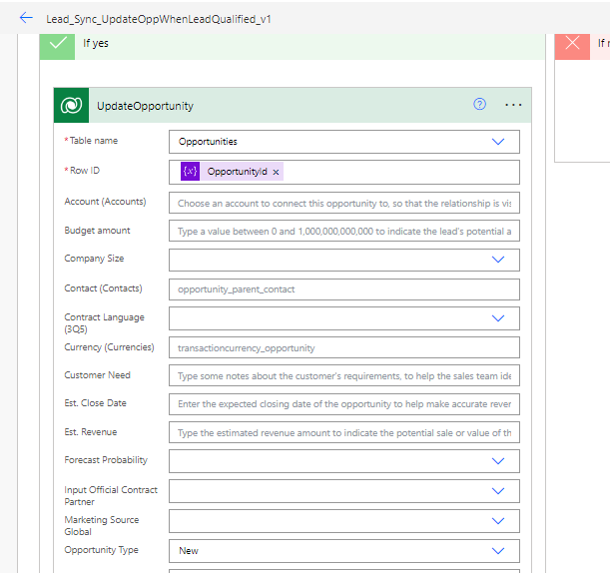

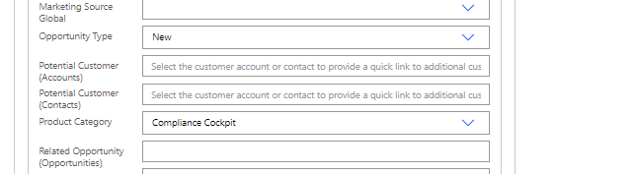

Flow Name: Update Opportunity Entity

[Edit your flow | Power Automate](https://make.powerautomate.com/environments/c9b9a3e8-c098-4ccc-83b2-e4c3ad6b6a60/flows/shared/9d521dd5-979e-4814-8cc4-768b1525b6c0)

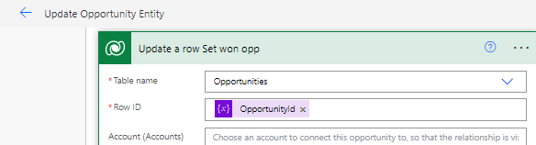



Workflow:

[Process: Email_Async_Create/Update_CopyEndDateToLastAcitivitiesOpportunity - Microsoft Dynamics 365](https://eqsgroup365.crm4.dynamics.com/sfa/workflow/edit.aspx?_CreateFromId={fd140aaf-4df4-11dd-bd17-0019b9312238}&_CreateFromType=7100&appSolutionId={fd140aaf-4df4-11dd-bd17-0019b9312238}&id={27577d6a-0d8c-4a8c-89fa-ce58f890a790})

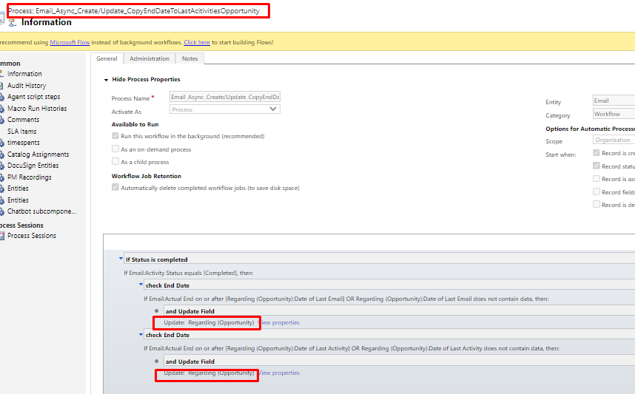

[Process: Note_Async_Create_CopyCreatedOnToLastNoteOpportunity - Microsoft Dynamics 365](https://eqsgroup365.crm4.dynamics.com/sfa/workflow/edit.aspx?_CreateFromId={fd140aaf-4df4-11dd-bd17-0019b9312238}&_CreateFromType=7100&appSolutionId={fd140aaf-4df4-11dd-bd17-0019b9312238}&id={55a7c907-c905-ee11-8f6e-000d3a649231})

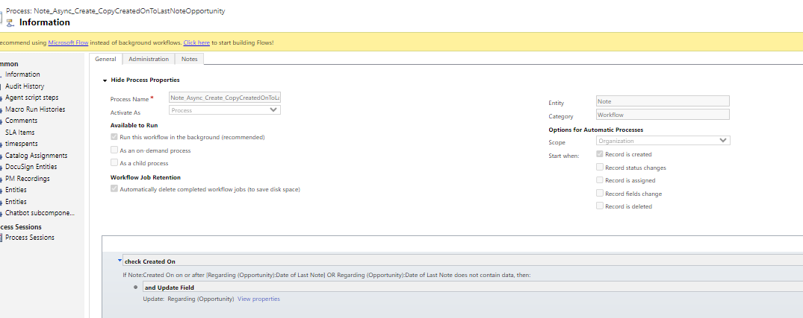

[Process: Opportunity Forecast Category Mapping Process - Microsoft Dynamics 365](https://eqsgroup365.crm4.dynamics.com/sfa/workflow/edit.aspx?_CreateFromId={fd140aaf-4df4-11dd-bd17-0019b9312238}&_CreateFromType=7100&appSolutionId={fd140aaf-4df4-11dd-bd17-0019b9312238}&id={1bbe3ecf-f3d4-4125-86d4-ae8a528c5fef})

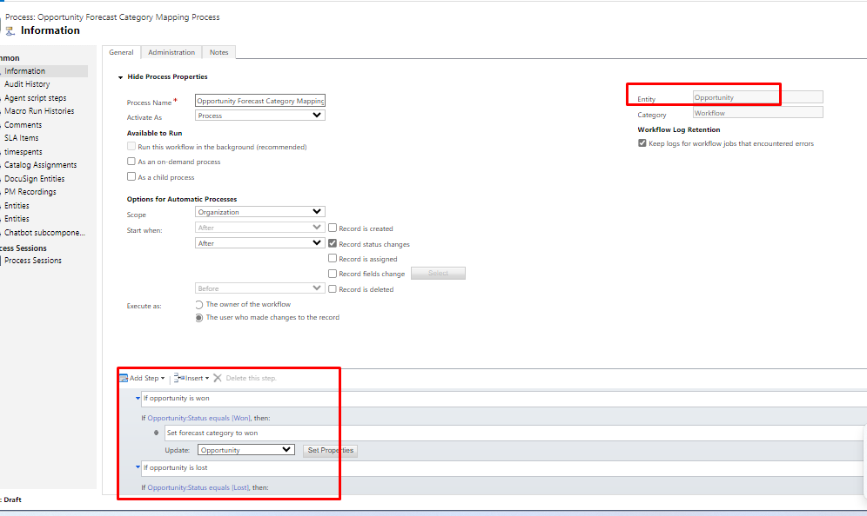

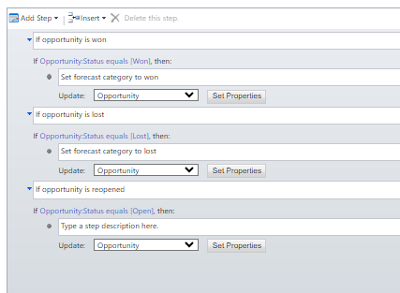

[Process: Opportunity_Async_Create/Update_IfCrossOrUpDownsellCopyContractNumberInRevisionNumber - Microsoft Dynamics 365](https://eqsgroup365.crm4.dynamics.com/sfa/workflow/edit.aspx?_CreateFromId={fd140aaf-4df4-11dd-bd17-0019b9312238}&_CreateFromType=7100&appSolutionId={fd140aaf-4df4-11dd-bd17-0019b9312238}&id={15fac82b-0158-43c5-b465-eb789c2573ba})

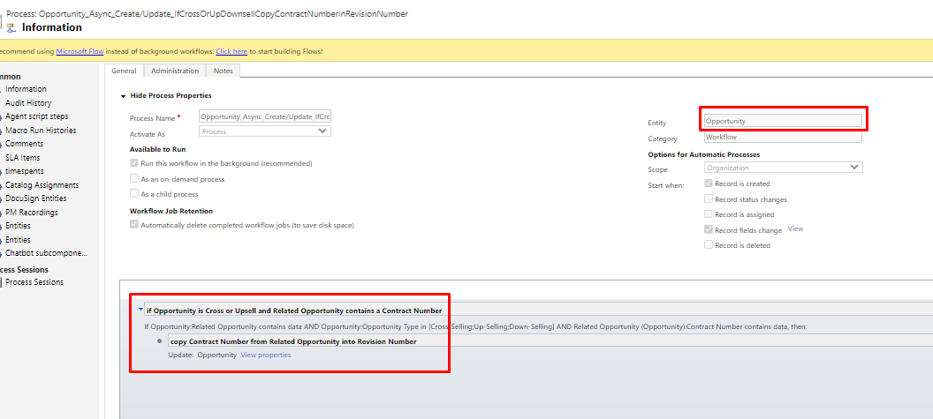

[Process: Opportunity_Async_Create_UpdateISOCodeFromAccount - Microsoft Dynamics 365](https://eqsgroup365.crm4.dynamics.com/sfa/workflow/edit.aspx?_CreateFromId={fd140aaf-4df4-11dd-bd17-0019b9312238}&_CreateFromType=7100&appSolutionId={fd140aaf-4df4-11dd-bd17-0019b9312238}&id={c7b40431-240e-42d2-bf73-c23bb9fa911e})

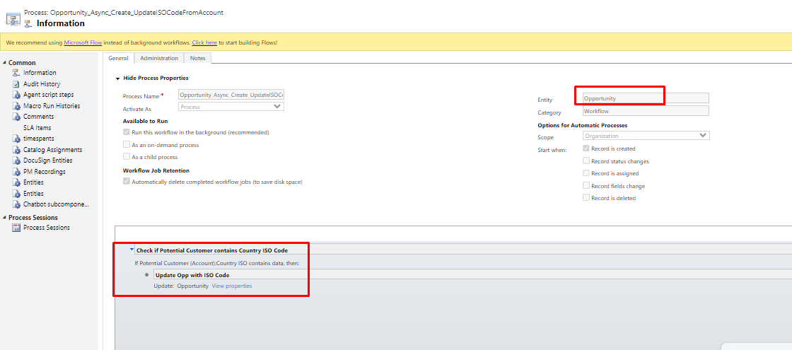

[Process: Opportunity_Async_Update_IfWonCheckOfficialContractPartnerAndSetTargetBusinessUnit - Microsoft Dynamics 365](https://eqsgroup365.crm4.dynamics.com/sfa/workflow/edit.aspx?_CreateFromId={fd140aaf-4df4-11dd-bd17-0019b9312238}&_CreateFromType=7100&appSolutionId={fd140aaf-4df4-11dd-bd17-0019b9312238}&id={4f0b9154-9ad9-4bbd-a9da-7e1b22aaa2f5})

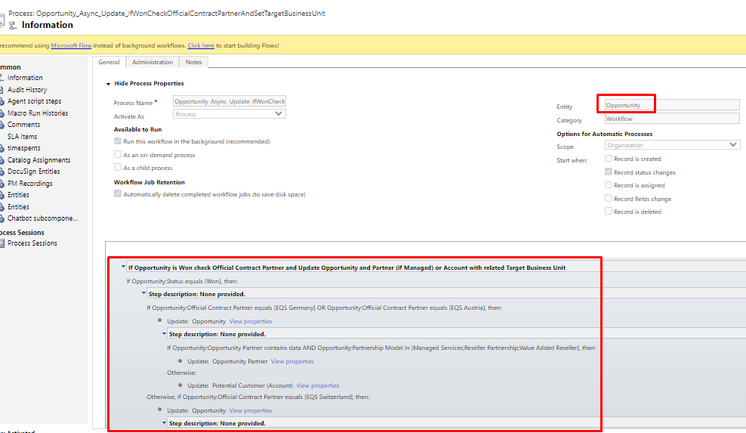

Long conditions, plz check conditions from url

[Process: Opportunity_Async_Update_IfWonSetCustomerSince - Microsoft Dynamics 365](https://eqsgroup365.crm4.dynamics.com/sfa/workflow/edit.aspx?_CreateFromId={fd140aaf-4df4-11dd-bd17-0019b9312238}&_CreateFromType=7100&appSolutionId={fd140aaf-4df4-11dd-bd17-0019b9312238}&id={ac91dbbe-63ed-ed11-8849-000d3ad9b1cd})

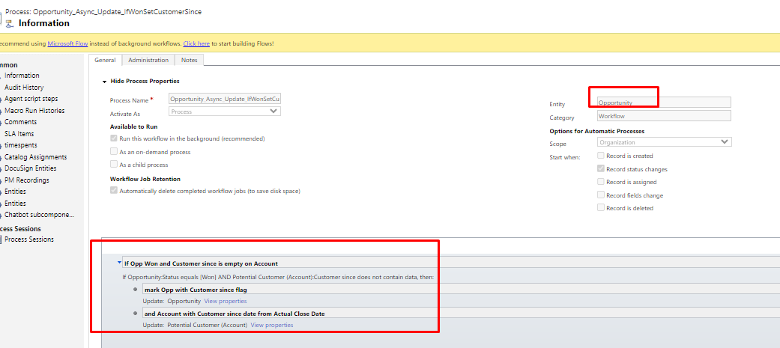

[Process: Opportunity_Async_UpdateContractNumber_SetContractStatus - Microsoft Dynamics 365](https://eqsgroup365.crm4.dynamics.com/sfa/workflow/edit.aspx?_CreateFromId={fd140aaf-4df4-11dd-bd17-0019b9312238}&_CreateFromType=7100&appSolutionId={fd140aaf-4df4-11dd-bd17-0019b9312238}&id={c29d3a11-5bf8-4126-943d-62a630b1153e})

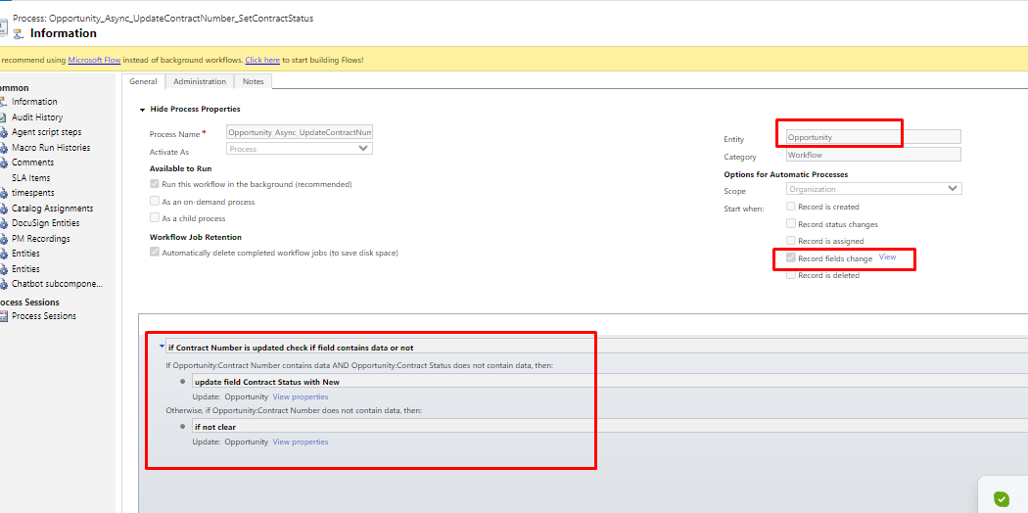

Triggering field is “contract number”

[Process: Opportunity_Async_UpdateStatus_UpdateAccountWithCustomer - Microsoft Dynamics 365](https://eqsgroup365.crm4.dynamics.com/sfa/workflow/edit.aspx?_CreateFromId={fd140aaf-4df4-11dd-bd17-0019b9312238}&_CreateFromType=7100&appSolutionId={fd140aaf-4df4-11dd-bd17-0019b9312238}&id={9ef004e5-bf18-4331-b727-aa1dfb1ce58c})

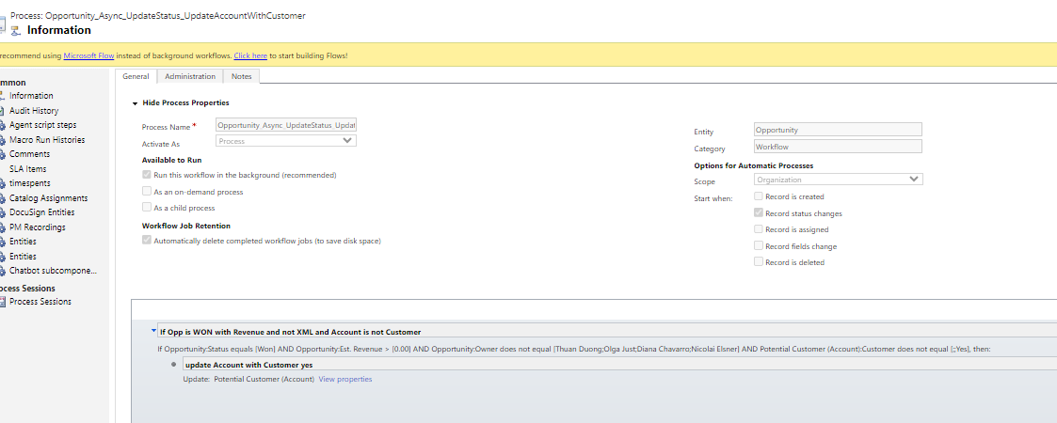

[Process: Opportunity_Async_UpdateStatus_UpdateAccountWithCustomer - Microsoft Dynamics 365](https://eqsgroup365.crm4.dynamics.com/sfa/workflow/edit.aspx?_CreateFromId={fd140aaf-4df4-11dd-bd17-0019b9312238}&_CreateFromType=7100&appSolutionId={fd140aaf-4df4-11dd-bd17-0019b9312238}&id={9ef004e5-bf18-4331-b727-aa1dfb1ce58c})

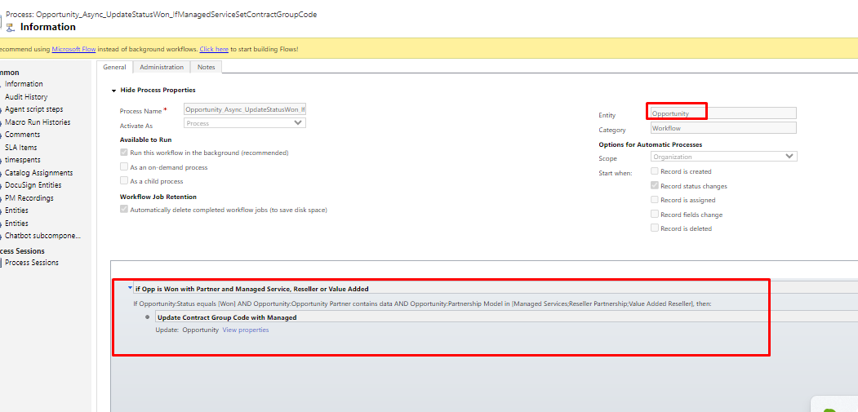

[Process: Opportunity_Async_UpdateStatusWON_UpdateConsentifReferenceYes - Microsoft Dynamics 365](https://eqsgroup365.crm4.dynamics.com/sfa/workflow/edit.aspx?_CreateFromId={fd140aaf-4df4-11dd-bd17-0019b9312238}&_CreateFromType=7100&appSolutionId={fd140aaf-4df4-11dd-bd17-0019b9312238}&id={aac81d79-0317-4e5a-9142-7417351e63de})

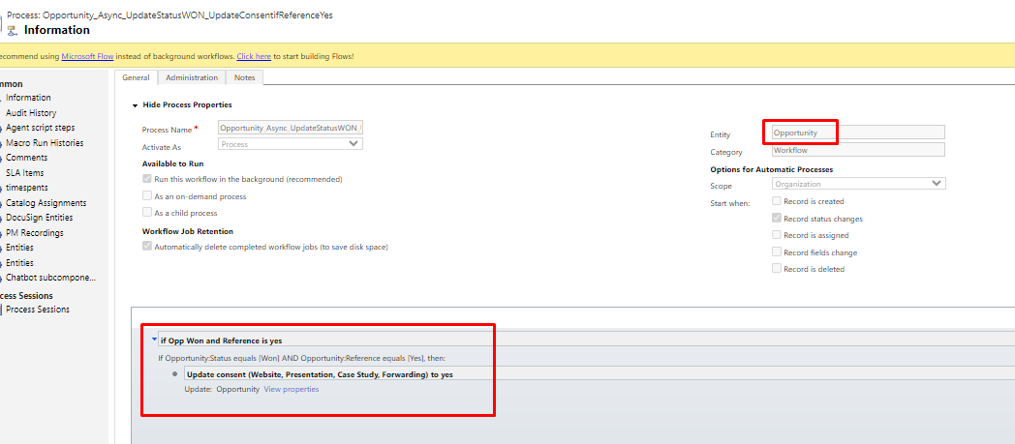

[Process: Opportunity_Sync_Create/Update_CopyInputToOfficialContractPartner - Microsoft Dynamics 365](https://eqsgroup365.crm4.dynamics.com/sfa/workflow/edit.aspx?_CreateFromId={fd140aaf-4df4-11dd-bd17-0019b9312238}&_CreateFromType=7100&appSolutionId={fd140aaf-4df4-11dd-bd17-0019b9312238}&id={21eec7d8-940a-ee11-8f6e-000d3ad9b1cd})

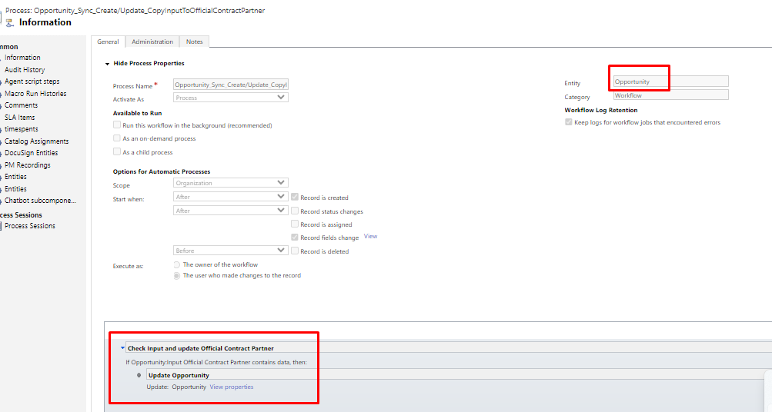

[Process: Opportunity_Sync_Create/UpdateCurrency_SetPriceListByCurrency - Microsoft Dynamics 365](https://eqsgroup365.crm4.dynamics.com/sfa/workflow/edit.aspx?_CreateFromId={fd140aaf-4df4-11dd-bd17-0019b9312238}&_CreateFromType=7100&appSolutionId={fd140aaf-4df4-11dd-bd17-0019b9312238}&id={c2d922a8-d722-4a53-9252-86ec44321559})

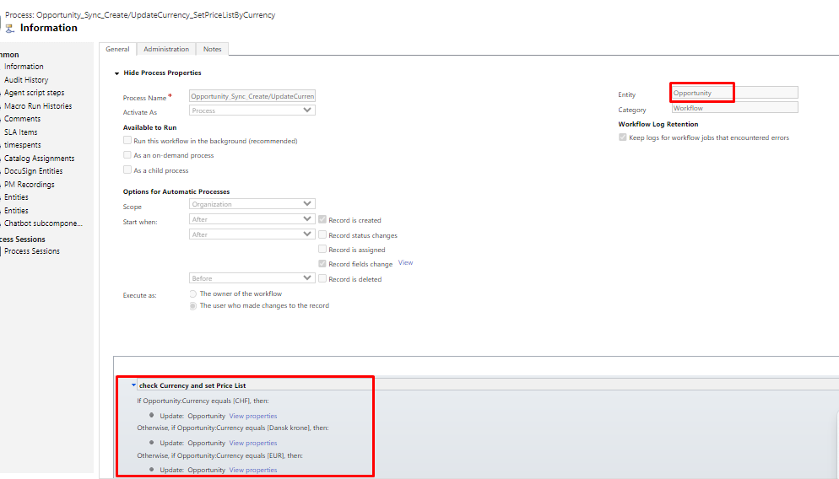

[Process: Opportunity_Sync_Create_CopyCompanySizeFromPotentialCustomer - Microsoft Dynamics 365](https://eqsgroup365.crm4.dynamics.com/sfa/workflow/edit.aspx?_CreateFromId={fd140aaf-4df4-11dd-bd17-0019b9312238}&_CreateFromType=7100&appSolutionId={fd140aaf-4df4-11dd-bd17-0019b9312238}&id={5b9a4e77-8d4a-434b-885d-87bc0db45116})

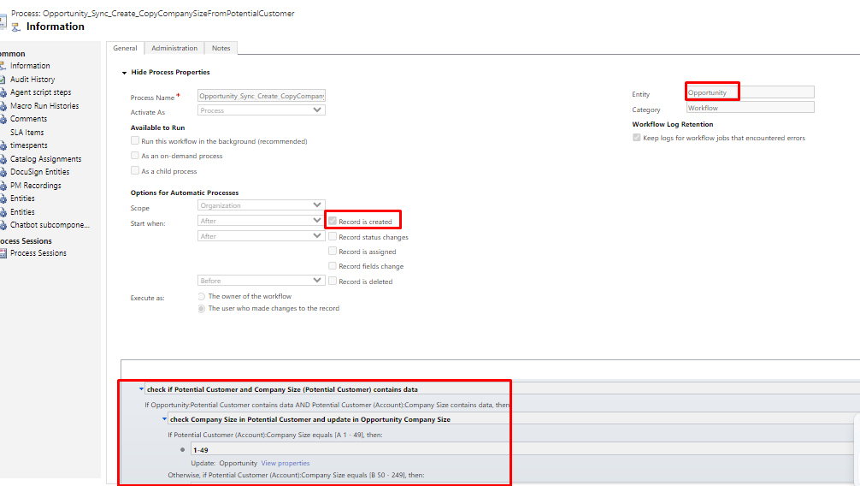

[Process: Opportunity_Sync_Create_IfComplianceCockpitAndNewStopandShowErrorMessage - Microsoft Dynamics 365](https://eqsgroup365.crm4.dynamics.com/sfa/workflow/edit.aspx?_CreateFromId={fd140aaf-4df4-11dd-bd17-0019b9312238}&_CreateFromType=7100&appSolutionId={fd140aaf-4df4-11dd-bd17-0019b9312238}&id={313e6f30-b461-49cf-a920-1b8d1d800ac1})

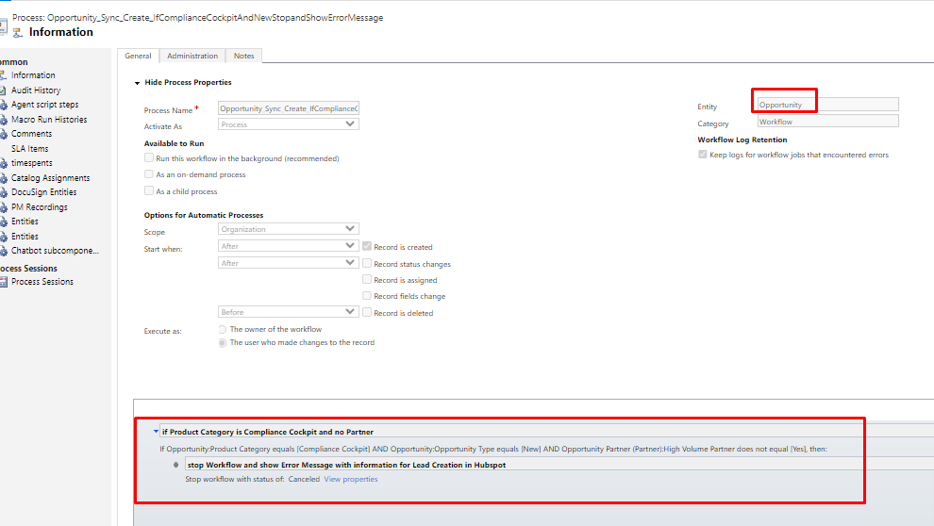

[Process: Opportunity_Sync_Deletion_IfStatusWonAndDeletionNotAllowedCancelWorkflow - Microsoft Dynamics 365](https://eqsgroup365.crm4.dynamics.com/sfa/workflow/edit.aspx?_CreateFromId={fd140aaf-4df4-11dd-bd17-0019b9312238}&_CreateFromType=7100&appSolutionId={fd140aaf-4df4-11dd-bd17-0019b9312238}&id={f2b18314-6251-40bb-acde-e5dab26f183e})

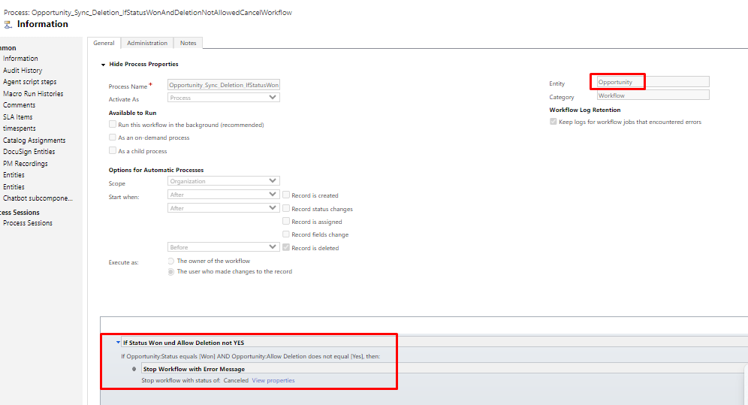

[Process: Opportunity_Sync_Update_CopyCompanySizeIntoPotentialCustomer - Microsoft Dynamics 365](https://eqsgroup365.crm4.dynamics.com/sfa/workflow/edit.aspx?_CreateFromId={fd140aaf-4df4-11dd-bd17-0019b9312238}&_CreateFromType=7100&appSolutionId={fd140aaf-4df4-11dd-bd17-0019b9312238}&id={857e1991-004d-4347-bb4e-4119e0abbdc4})

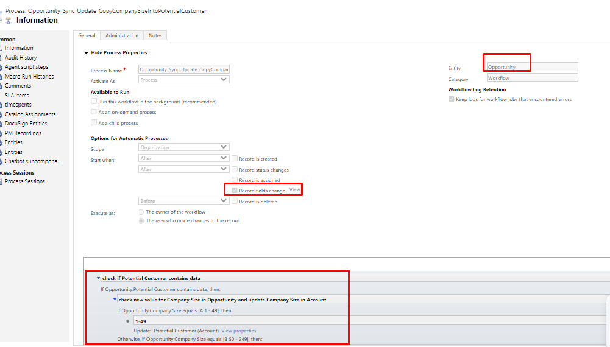

[Process: Opportunity_Sync_UpdateRollupActualLicenseFeeAfterExchangeRate - Microsoft Dynamics 365](https://eqsgroup365.crm4.dynamics.com/sfa/workflow/edit.aspx?_CreateFromId={fd140aaf-4df4-11dd-bd17-0019b9312238}&_CreateFromType=7100&appSolutionId={fd140aaf-4df4-11dd-bd17-0019b9312238}&id={733f8b45-d5bc-ed11-83ff-000d3ad9b1cd})

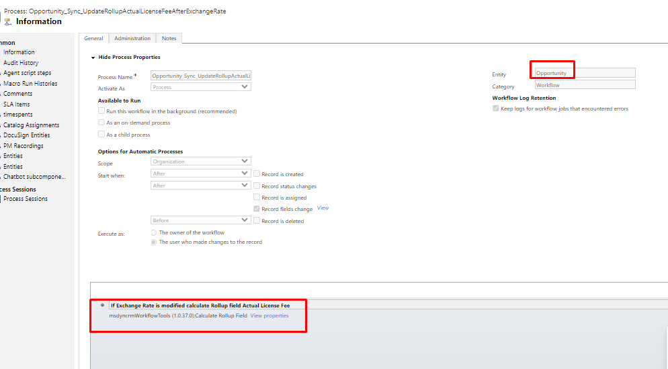

[Process: Partner Process Cancellation - Microsoft Dynamics 365](https://eqsgroup365.crm4.dynamics.com/sfa/workflow/edit.aspx?_CreateFromId={fd140aaf-4df4-11dd-bd17-0019b9312238}&_CreateFromType=7100&appSolutionId={fd140aaf-4df4-11dd-bd17-0019b9312238}&id={d23c038f-03f9-4dc3-b0ea-fddf3742c870})

[Process: PhoneCall_Async_Create/Update_CopyEndDateToLastAcitivitiesOpportunity - Microsoft Dynamics 365](https://eqsgroup365.crm4.dynamics.com/sfa/workflow/edit.aspx?_CreateFromId={fd140aaf-4df4-11dd-bd17-0019b9312238}&_CreateFromType=7100&appSolutionId={fd140aaf-4df4-11dd-bd17-0019b9312238}&id={82ede14a-643f-479b-8a78-fec4bc61dcc7})

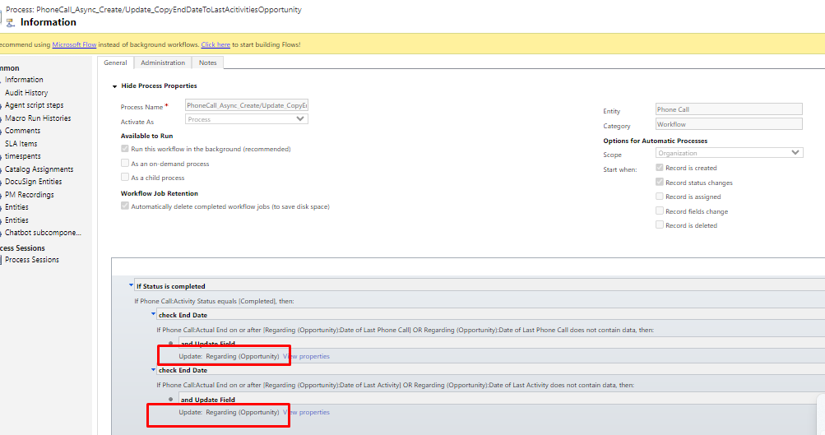

[Process: Prefill opportunities when generated - Microsoft Dynamics 365](https://eqsgroup365.crm4.dynamics.com/sfa/workflow/edit.aspx?_CreateFromId={fd140aaf-4df4-11dd-bd17-0019b9312238}&_CreateFromType=7100&appSolutionId={fd140aaf-4df4-11dd-bd17-0019b9312238}&id={1c0c6ed3-2863-4bf2-b3b0-04ec2247d8d7})

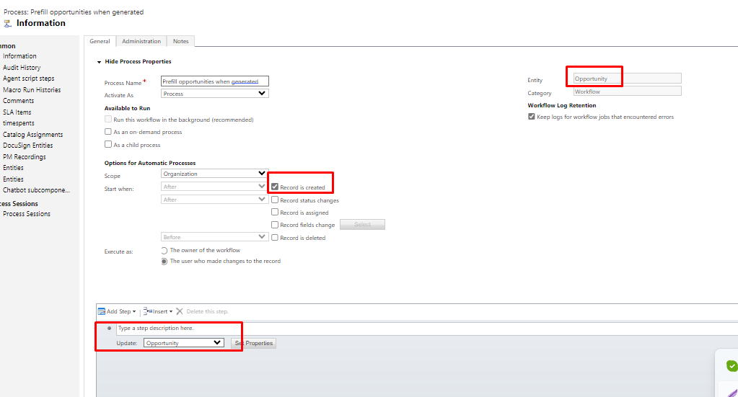

[Process: Scaleable.Xrm.WorkFlow.OPLost.UpdateXMLStatus - Microsoft Dynamics 365](https://eqsgroup365.crm4.dynamics.com/sfa/workflow/edit.aspx?_CreateFromId={fd140aaf-4df4-11dd-bd17-0019b9312238}&_CreateFromType=7100&appSolutionId={fd140aaf-4df4-11dd-bd17-0019b9312238}&id={3873389f-12eb-4737-8072-b72d0acbac87})

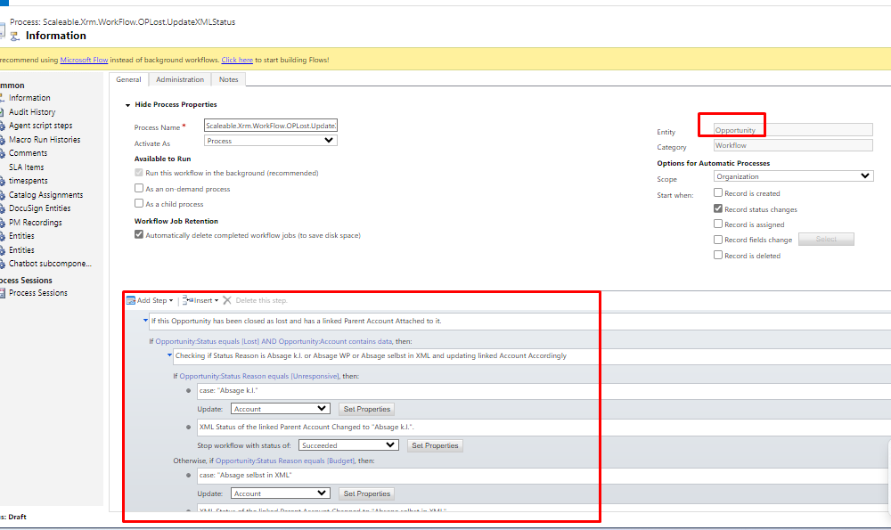

[Process: Scaleable.Xrm.Workflows.OPWon.UpdateAccXMLStatus - Microsoft Dynamics 365](https://eqsgroup365.crm4.dynamics.com/sfa/workflow/edit.aspx?_CreateFromId={fd140aaf-4df4-11dd-bd17-0019b9312238}&_CreateFromType=7100&appSolutionId={fd140aaf-4df4-11dd-bd17-0019b9312238}&id={f1cea9c5-f284-4463-a5c2-75a56639ab9f})

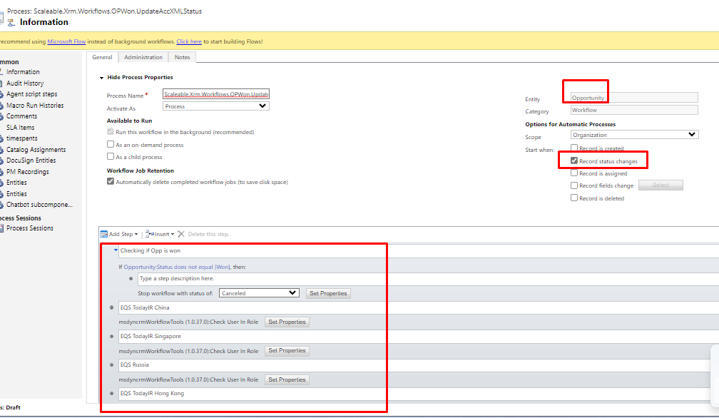

[Process: Template_Attachment - Microsoft Dynamics 365](https://eqsgroup365.crm4.dynamics.com/sfa/workflow/edit.aspx?_CreateFromId={fd140aaf-4df4-11dd-bd17-0019b9312238}&_CreateFromType=7100&appSolutionId={fd140aaf-4df4-11dd-bd17-0019b9312238}&id={7a7de43b-621e-4f3d-821e-d38babb3ec84})

